**User Manual**

**(Benutzerhandbuch)**

(TINF18C, SWE I Praxisprojekt 2019/2020)

*Project: DD2AML Converter*

*Customer: Rentschler & Ewertz*

Rotebühlplatz 41

70178 Stuttgart

*Supplier: by Nora Baitinger - Team 3   
 (Nora Baitinger, Antonia Wermerskirch, Lara Mack, Bastiane Storz)*

Rotebühlplatz 41

70178 Stuttgart

|  |  |  |  |
| --- | --- | --- | --- |
| **Version** | **Date** | **Author** | **Comment** |
| 0.1 | 07.09.2018 |  | created |
| 0.1 | 03.05.20 20 | Nora Baitinger | Filled with information |
| 1.0 | 10.05.2020 | Nora Baitinger | Added CLI and GUI |

# Content

1 Content 2

2 Figures 3

3 Glossar 4

4 Introduction 5

5 Installation 6

5.1 Software requirements 6

5.2 Installation process 6

6 Command Line Interface 7

6.1 Usage 7

6.2 Options 7

6.3 Examples 8

6.3.1 Conversion to AMLX 8

6.3.2 Conversion to string 8

7 Graphical User Interface 9

7.1 General 9

7.2 Usage 9

7.2.1 Successful conversion 9

7.2.2 Example for unsuccessful conversion 10

7.3 Copyright 11

8 Log files 12

8.1 Storage location 12

8.2 Log Files 12

8.2.1 Successful conversion 12

8.2.2 Conversion with flawed DD-file 13

# Figures

Figure 1 - CLI help text 7

Figure 2 - Conversion to AMLX successful 8

Figure 3 - Generated AMLX output path 8

Figure 4 - Conversion to string successful 8

Figure 5 - GUI start window 9

Figure 6 – Conversion with GUI 9

Figure 7 - GUI Conversion successful 10

Figure 8 - Open in AML Editor 10

Figure 9 - Conversion with flawed DD-file 10

Figure 10 - Copyright GUI 11

[Figure 11 - CLI logs storage location 12](https://d.docs.live.net/e4d1a8a509920803/00_Schule/3.Semester/Software_Projekt/User%20Manual/TINF18C_User_Manual_Team_3_v1.0.docx#_Toc40100661)

Figure 12 - GUI logs storage location 12

Figure 13 - Log file successful conversion 12

Figure 14 - Log file unsuccessful conversion 13

# Glossar

**.NET The .NET Framework is a software development and runtime environment developed by Microsoft for Microsoft Windows.**

**AML** Automation Markup Language is an open standard data format for storing and exchanging plant planning data.

**AML DD** AML Device Description

**AMLX** AML Package

**CAEX** Computer-Aided Engineering Exchange

**CLI** Command Line Interface

**CSP+** Control and Communication System Profile

**GUI** Graphical User Interface

**GSD** General-Station-Description

**IODD** Input/Output Device Description

**PN** Profinet

**ZIP** ( zipper ) is an archive file format that supports lossless data compression

# Introduction

The main usage of the DD2AML-Converter is the conversion of a DD-File with the formats GSD, IODD and CSP+ to an AML file or even an AML Package.

AML is a file format developed as an exchange format with an open standard. For interoperability and an easier exchange, the data is normalized by conversion to AML.

To achieve this conversion there are three different ways:

1. The conversion can be done via a Command Line Interface (CLI).
2. The conversion can be started and the results get via a Graphical User Interface (GUI), especially for those who feel uncomfortable with a CLI.
3. Developers can use the Library - that is the main part of the software - to convert DD-files as well but return the corresponding AML file as a string to work with it in their own projects.

This software will be used in environments where users need to manage engineering data for Profinet devices. The data about Profinet devices can be saved in different xml based files like PN-GSD, IODD or CSP+. These files contain the basic information about what the Profinet device is capable of.

The DD2AML-Converter supports the conversion of syntactically valid GSD, IODD and CSP+ files. The returning AML file uses either the CAEX Version 2.15 or the newer CAEX Version 3.0. All the files referring to the original DD-file are saved within the AML Package (AMLX).

# Installation

## Software requirements

The software requires the .NET Framework to be installed in Version 4.7 or higher. As a result, a PC with Windows 7 SP 1 or later is also required.

## Installation process

To install the Command Line Interface and the Graphical User Interface, it is sufficient to download the installer available under [*https://github.com/WAntonia/TINF18C_Team_3_DD2AML-Converter/releases*](https://github.com/WAntonia/TINF18C_Team_3_DD2AML-Converter/releases) *.* After downloading it, the users only need to follow the guidance of the installation wizard to install the program.

During the installation process, users can select the installation for all users working on the PC or only the current user. It is also possible to select the folder where the software should be installed and if a desktop icon and/or a shortcut into the start menu shall be created.

Users have the possibility to repair or uninstall the program using the installer again.

Please, notice that it is not possible to install only the CLI or the GUI.

The second possibility to get the program, is to download the provided zip file, available under [*https://github.com/WAntonia/TINF18C_Team_3_DD2AML-Converter/releases*](https://github.com/WAntonia/TINF18C_Team_3_DD2AML-Converter/releases) as well, and extracting the content into a folder on the local disk. So, no installation is needed necessarily.

# Command Line Interface

Ein Bild, das Screenshot, schwarz, sitzend, Monitor enthält.

Figure 1 - CLI help text

## Usage

There are two ways how the CLI can output the result of the conversion:

1. The generated AMLX file containing the AML root file, the original DD-file and all the other referred files like pictures of the device.
2. A string containing the content of the AML file.

After the installation of the program is finished, it is possible to call the help using the commands “dd2aml” or “dd2aml –help” in a terminal.

To start the conversion of a DD-file that is one of the listed formats (GSD, IODD or CSP+) to AML the file path must be entered after “dd2aml”.

## Options

There are also a view different parameters that can be set to influence certain factors of the conversion:

|  |  |
| --- | --- |
| **Parameter** | **Description and value range** |
| -i, --input ‘file’ (required) | The path to the DD-file you want to convert.  For example: ‘C:\Users\User\Documents\example-IODD1.1.xml’ |
| -o, --output ‘file’  (optional) | Set the path of the output directory. Default is the input path of the given DD-file. The path must end with the name of the AMLX package, for example:  ‘C:\Users\User\Documents\example_package.amlx’ |
| -s, --string (optional) | Set the output type to a string instead of storing a file. |
| -n, --novalidate (optional) | Do not validate the input DD-file. |
| -v, --version (optional) | Decide the AML CAEX Version. Choose either Version 2.15 or Version 3.0.  Users need to enter either 2 (for Version 2.15) or 3 (for Version 3.0).  The default value is CAEX Version 2.15. |

Note: --output and –string can’t be used together

## Examples

### Conversion to AMLX

Enter the following parameter to get result shown in the picture below:

* i "C:\Users\User\Documents\IODD_Datei\Example-IODD1.1.xml"
* o "C:\DD2AML\IODD_Example.amlx"
* v 3

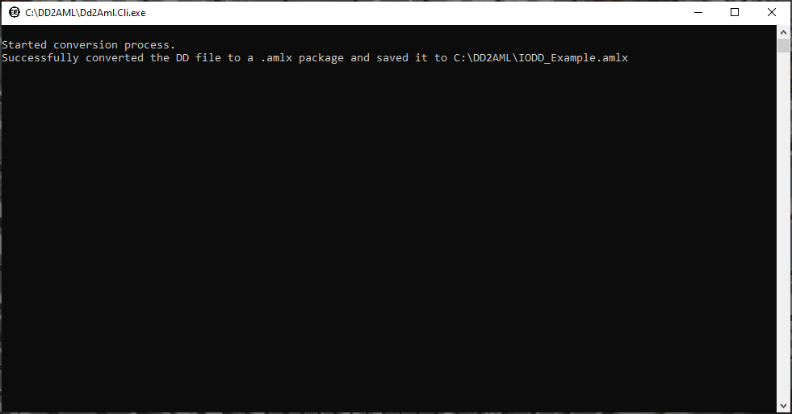

Figure 2 - Conversion to AMLX successful

You will find the package at your requested output path:

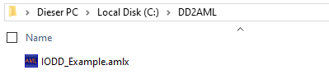

Figure 3 - Generated AMLX output path

### Conversion to string

Enter the following parameter to get result shown in the picture below:

* i "C:\Users\User\Documents\IODD_Datei\Example-IODD1.1.xml"
* s
* v 3

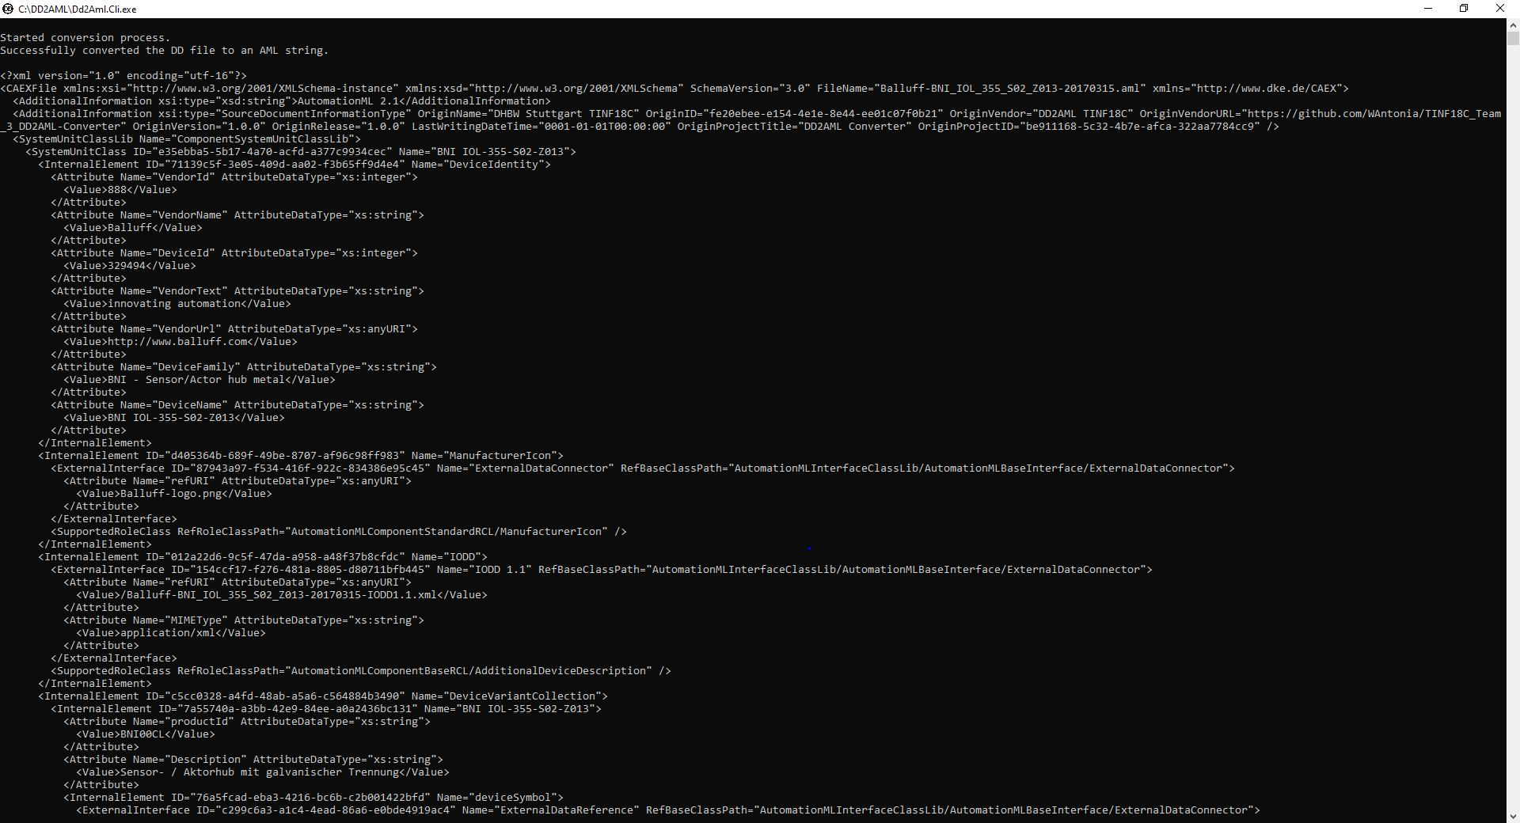

Figure 4 - Conversion to string successful

# Graphical User Interface

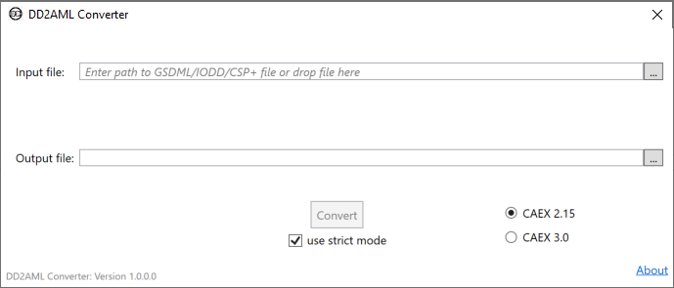

Figure 5 - GUI start window

## General

The graphical user interface is designed especially for users who feel unfamiliar with the command line interface.

The GUI is also used to convert a DD-file to AML. However, it is only possible to generate an AMLX file containing the AML root file, the original DD-file and the other references of the device descriptions like pictures.

## Usage

### Successful conversion

Please enter the following information:

* Input file: The path where the DD-file is stored that you want to convert to AML.  
  Either use drag and drop to enter the file or write the file path into the text box. You can also use the explorer dialog, clicking on the … button.
* Output file: The location where the generated AMLX Package will be stored.  
  Enter the location or use the explorer dialog.

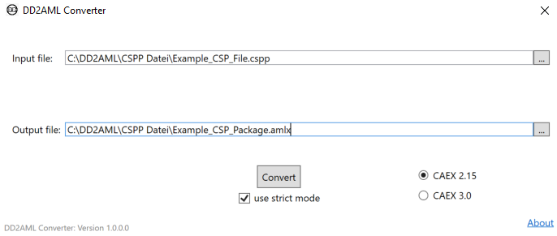

Figure 6 – Conversion with GUI

* After clicking on the Convert button, the conversion will start.

When the conversion has been successful, you will see the following:

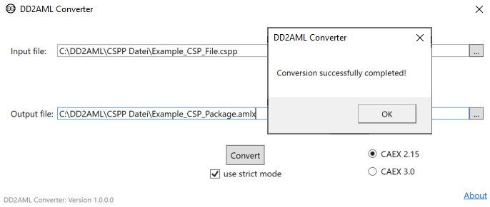

Figure 7 - GUI Conversion successful

Then you will be asked if you want to open the generated AMLX Package in the AML Editor:

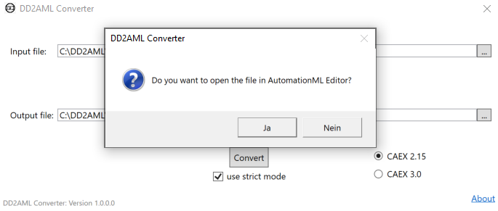

Figure 8 - Open in AML Editor

There you can have a look at the generated AMLX package.

### Example for unsuccessful conversion

When the given DD-file is incorrect regarding the syntax of its format, you will receive an error message containing the error in the given DD-file:

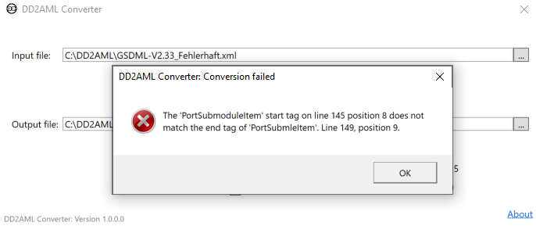

Figure 9 - Conversion with flawed DD-file

## Copyright

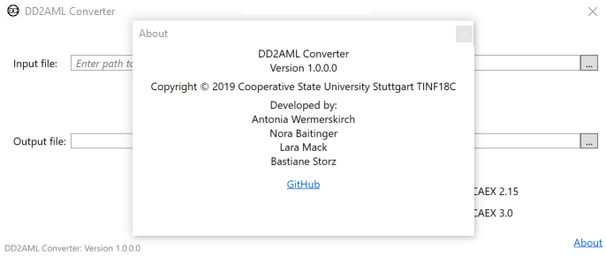

Figure 10 - Copyright GUI

# Log files

The software provides the user with information about the status of the program and the conversion process. Therefore, the software creates log files for every conversion with the CLI and the GUI.

The files are stored under the following file path: ‘C:\Users\${User}\AppData\Local\DD2AML\Logs’.

Users can access the log files very easily by entering ‘%LOCALAPPDATA%’ in the navigation bar of the Windows Explorer. Users will see a list of folders and need to search for ‘DD2AML’. If the folder does not exist, the program hasn’t been used yet and no logs have been created.

Log files are stored for every execution of the CLI or the GUI. The file names contain the timestamp of the execution and the messages include information about the log level and which logger (GUI or CLI) generated it.

## Storage location

**GUI**  **CLI**

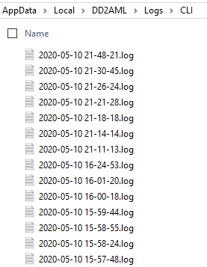 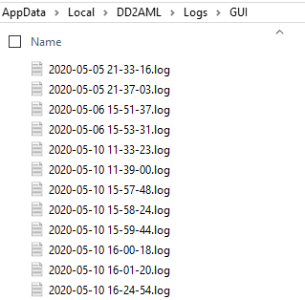

Figure 11 - CLI logs storage location

Figure 12 - GUI logs storage location

## Log Files

### Successful conversion

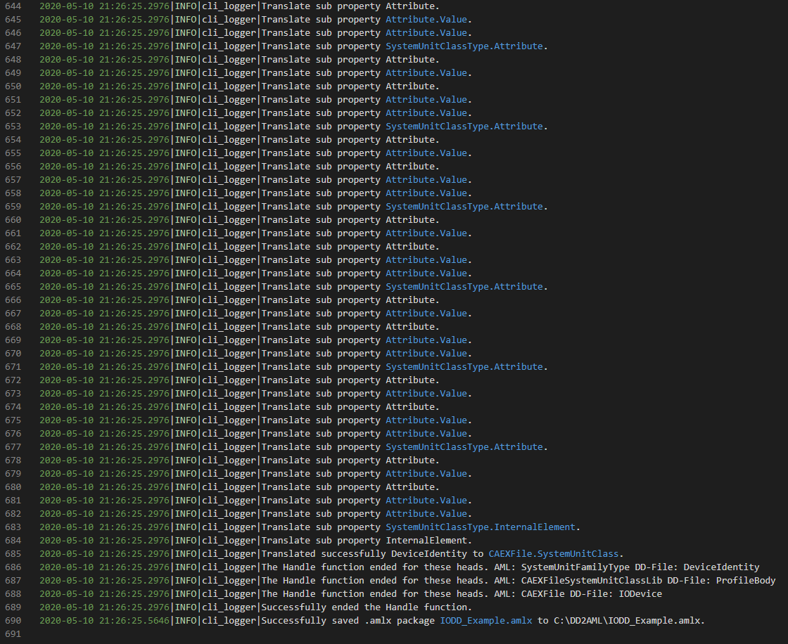

Figure 13 - Log file successful conversion

### Conversion with flawed DD-file



Figure 14 - Log file unsuccessful conversion